1.

If set N is a subset of set M, then
A.
sets M and N have the same number of elements.
B.
some members of set N can be found in set M
C.
no member of set N is in set M.
D.
all members of set N are in set M.

2.

The Venn diagram shows the number of pupils who offer Mathematics (M) and/or English (E) in a class.
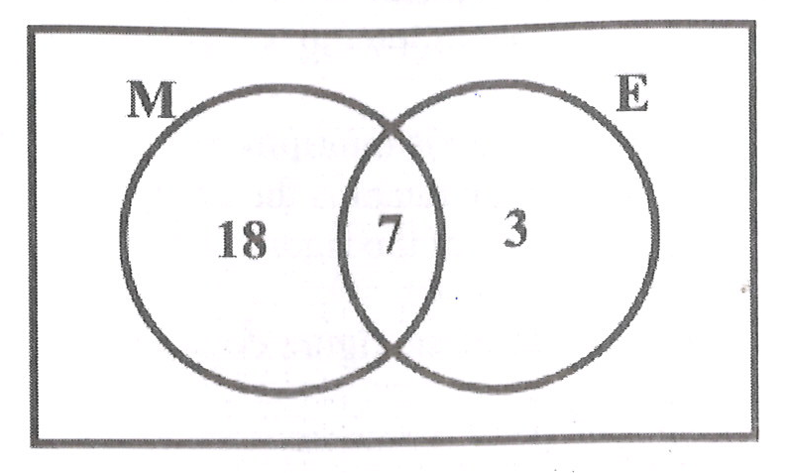
Use this information to answer the question below.
How many pupils offer Mathematics?
A.
10
B.
18
C.
25
D.
28

3.

The Venn diagram shows the number of pupils who offer Mathematics (M) and/or English (E) in a class.
Use this information to answer the question below.
How many pupils offer only one subject?
A.
3
B.
7
C.
18
D.
21

4.

Simplify: 12 - 7 - (-5).
A.
-10
B.
-2
C.
0
D.
10

5.

Express 72 as a product of its prime factors.
A.
2 x 3³
B.
2² x 3²
C.
2³ x 3
D.
2³ x 3²

6.

Find the smallest number which is divisible by 16 and 20?
A.
40
B.
80
C.
120
D.
160

7.

Convert 243_{five} to a base ten numeral.
A.
40
B.
43
C.
45
D.
73

8.

A pineapple which was bought for GH₵1.00 was sold at GH₵1.30. Calculate the profit percent.
A.
10%
B.
20%
C.
23%
D.
30%

9.

Simplify 35x⁵y³ ÷ 7xy²
A.
5x⁴y
B.
5x⁴y⁵
C.
5x⁶y
D.
5x⁶y⁵

10.

Two bells P and Q ring at intervals of 3 hours and 4 hours, respectively. After how many hours will the two bells first ring simultaneously (at the same time)?
A.
6 hours
B.
8 hours
C.
12 hours
D.
24 hours

11.

A boy scores
17
25
in a French test. Express his score as a percentage.
A.
17%
B.
34%
C.
68%
D.
85%

12.

Arrange the following fractions in ascending order of magnitude,
2
5
,
5
12
and
3
4
.
A.
2
5
,
3
4
,
5
12
B.
2
5
,
5
12
,
3
4
C.
5
12
,
2
5
,
3
4
D.
3
4
,
2
5
,
5
12

13.

Kofi paid rent of GH₵1,800.00 each year. If the rent is 0.3 of his annual income, find his annual income.
A.
GH₵600.00
B.
GH₵5,400.00
C.
GH₵6,000.00
D.
GH₵18,000.00

14.

I gave a storekeeper a GH₵10.00 note for goods I bought. He asked me for another 15 Gp for ease of change. If he then gave me 50 Gp, how much did I pay for the goods?
A.
GH₵9.35
B.
GH₵9.45
C.
GH₵9.65
D.
GH₵10.65

15.

Kojo can buy 15 shirts at GH₵4.00 each. If the price is increased to GH₵5.00, how many shirts can he now buy?
A.
12
B.
15
C.
19
D.
20

16.

A hall which is 8 m long is represented on a diagram as 4 cm long. What is the scale of the diagram?
A.
1 : 200
B.
1 : 250
C.
1 : 400
D.
1 : 800

17.

Jane arrived at work at 7:55 a.m and left at 4:15 p.m. For how long was she at work?
A.
7 hr 20 min
B.
7 hr 45 min
C.
8 hr 20 min
D.
8 hr 40 min

18.

Given that (3.14 x 18) x 17.5 = 3.14 x (3p x 17.5)
Find the value of p.
A.
3.0
B.
5.8
C.
6.0
D.
9.0

19.

The pie chart shows how Kwaku spends his monthly salary.
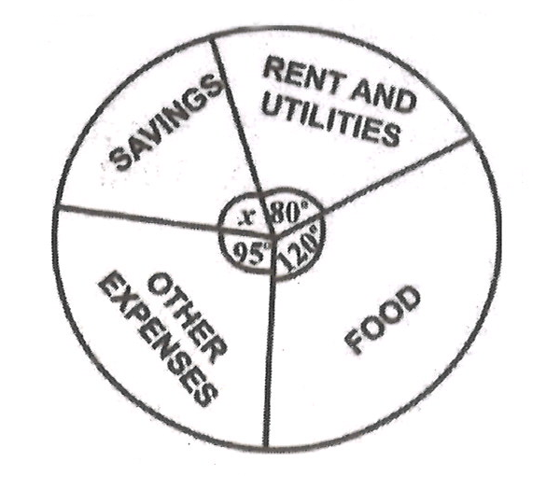
Use this information to answer the question below.
Find the value of x.
A.
65º
B.
75º
C.
85º
D.
100º

20.

The pie chart shows how Kwaku spends his monthly salary.
Use this information to answer the question below.
Kwaku earns GH₵630.00 a month. How much of this does he spend on food?
A.
GH₵140.00
B.
GH₵157.00
C.
GH₵210.00
D.
GH₵350.00

21.

The pie chart shows how Kwaku spends his monthly salary.
Use this information to answer the question below.
What percentage of his salary does he spend on rent and utilities?
A.
12.1%
B.
12.5%
C.
22.2%
D.
33.3%

22.

In an enlargement with scale factor 2, which of the following statements is not true?
A.
Each length is multiplied by 2.
B.
Each angle remains the same.
C.
The shape of the figure does not change.
D.
The size of the figure does not change.

23.

Kofi, Kojo and Ama shared GH₵480,000.00 in the ratio 3:5:4.
How much did Ama receive?
A.
GH₵160,000.00
B.
GH₵200,000.00
C.
GH₵218,181.81
D.
GH₵342,859.14

24.

If w = 12, x = 5, y = 6 and z = 4, find the value of wx - yz.
A.
18
B.
27
C.
36
D.
84

25.

A man was 24 years old when his son was born. Now he is three times as old as his son. Find the age of the son.
A.
6 years
B.
12 years
C.
18 years
D.
36 years

26.

There are 20 identical balls in a box. Twelve are blue and the rest are green. If one ball is taken at random from the box, find the probability that the ball is green.
A.
1
20
B.
2
5
C.
3
5
D.
3
4

27.

Using the following mapping, find the missing numbers p and q.
x | 1 | 2 | 3 | 4 | 5 | 6
↓ | ↓ | ↓ | ↓ | ↓ | ↓ | ↓
y | 3 | 5 | p | 9 | 11 | q
A.
p = 6, q = 12
B.
p = 6, q = 13
C.
p = 7, q = 12
D.
p = 7, q = 13

28.

The perimeter of rectangle is 24 cm. If the length is 7 cm, find its width.
A.
3 cm
B.
5 cm
C.
10 cm
D.
12 cm

29.

A boy walks on a bearing 070º. Which of the following diagrams show his direction?
A.
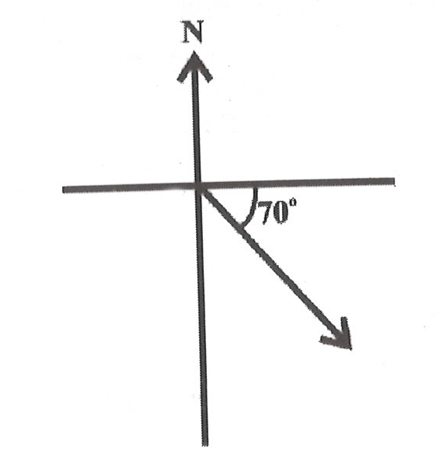
B.
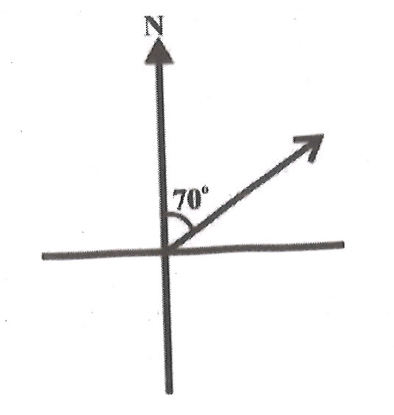
C.
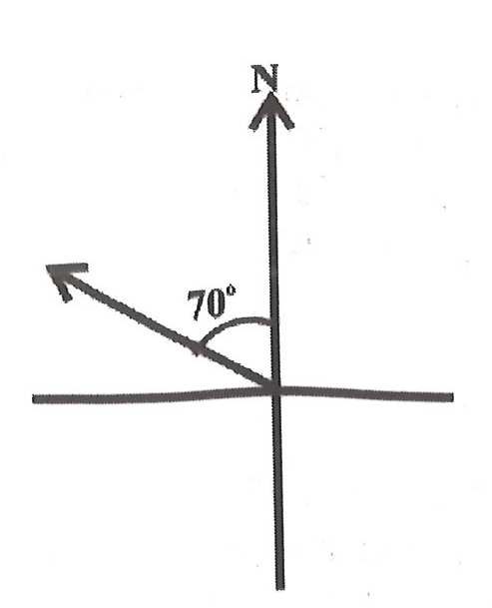
D.
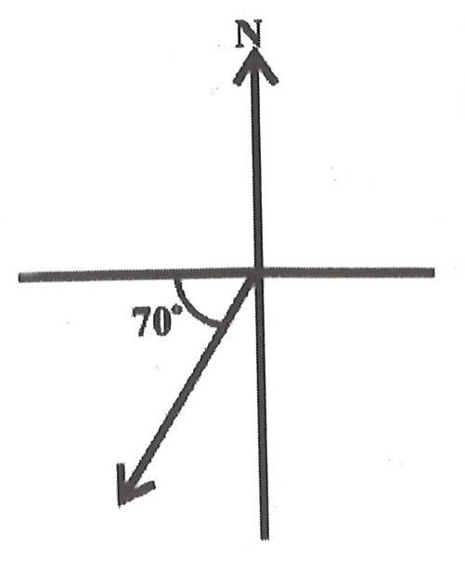

30.

How many faces has a cube?
A.
4
B.
6
C.
8
D.
12

31.

The diameter of a circular tray is 28 cm. Find the area of the tray.
[Take π =
22
7
]
A.
44 cm²
B.
88 cm²
C.
154 cm²
D.
616 cm²

32.

Calculate the volume of a cylinder with radius 7 cm and height 10 cm.
[Take π =
22
7
]
A.
220 cm³
B.
440 cm³
C.
1,540 cm³
D.
3,080 cm³

33.

Use the diagram below to answer the question below.
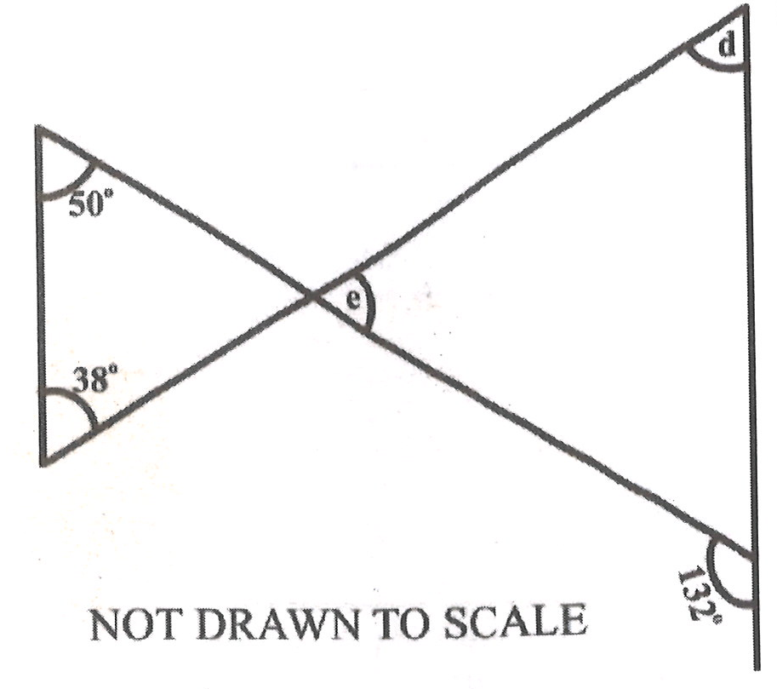
Find the value of e.
A.
38º
B.
40º
C.
88º
D.
92º

34.

Use the diagram below to answer the question below.
Find the angle marked d.
A.
38º
B.
40º
C.
48º
D.
88º

35.

A 3.6 m long string is to be cut into pieces, each of length 40 cm. How many pieces can be cut from the string?
A.
4
B.
6
C.
8
D.
9

36.

Solve the inequality 2x + 10 ≥
7x
2
- 5
A.
x ≤ 10
B.
x ≥ 10
C.
x ≤ 40
D.
x ≥ 40

37.

The point P(5,4) is reflected in the y-axis. Find its image.
A.
(-5,4)
B.
(5,-4)
C.
(-4,5)
D.
(4,-5)

38.

If
(
4
11
)
=
(
x - 3
11
)
, find the value of x.
A.
-1
B.
1
C.
7
D.
12

39.

Find the gradient of the line which passes through the points M(-1,2) and N(6,-3).
A.
-5
7
B.
-7
5
C.
5
7
D.
7
5

40.

Find the next two terms in the sequence 11,7,3,-1,...,...
A.
5,9
B.
3,7
C.
-4,-9
D.
-5,-9

